**Maven Life Cycle**

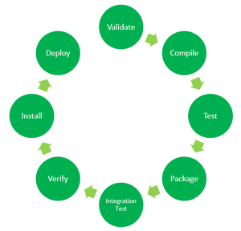

|  |  |
| --- | --- |
| **mvn** **clean** | Invoking clean phase of Clean LifeCycle |
| **mvn** **compile** | Invoking compile phase of Default Lifecycle |
| **mvn** **clean package** | Invoking clean phase of Clean Lifecycle followed by package phase of Default Lifecycle. |
| **mvn** **clean install** | Invoking clean phase of Clean Lifecycle followed by install phase of Default Lifecycle. |
| **mvn** **test** | Invoking test phase of Default Lifecycle. |
| **mvn** **dependency:list** | Invoking list goal of dependency plugin (a tool, not bound to any phase by default) |
| **mvn** **help:effective-pom** | Invoking effective-pom goal of help plugin(tool) |

mvn –version : it will show which version of maven after installation. Current maven version is 3.8.5.

mvn – compile : Compile source code of the project.

mvn --test : Specify test classes or methods we want to execute. Compile all tests without running them.

mvn -- install : Download the latest version and select maven zip file. It head over to Apache Maven site to install.

mvn –clean : Clean files and directories generated by maven during build.

WHAT IS WEB SERVICES ?

* It is a client-server application or application component for communication.
* The method of communication between two devices over the network.
* It is a software system for the interoperable machine to machine communication.
* It is a collection of standards or protocols for exchanging information between two devices or application.

what is rest controller

Spring annotation that is used to build API in a declarative way. RestController is used for **making restful web services**with the help of the @RestController annotation.

get : getting data from Web API, which allow API consumer to fetch data from API, now in one API we can have multiple Get methods

post: **send data to a server to create/update a resource.** The data sent to the server with POST is stored in the request body of the HTTP request

put : creates a new resource or replaces a representation of the target resource with the request payload.

delete: used to delete a resource identified by requested URI. DELETE operation is idempotent which means.

**Git life cycle**

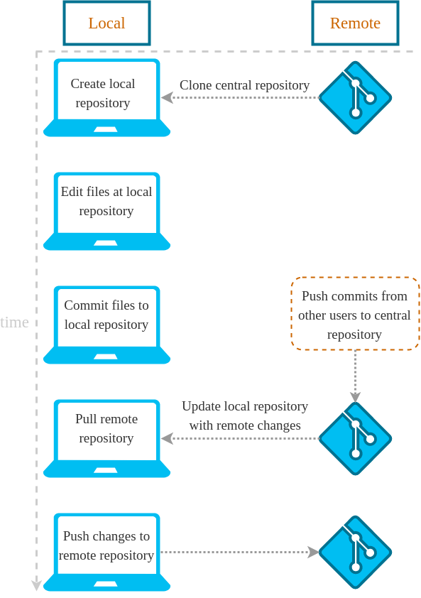

Git commands

* git init: the**first command that you will run on Git**. The git init command is used to create a new blank repository. It is used to make an existing project as a Git project.
* git add : **add file contents to the Index (Staging Area)**
* git commit : created with the git commit command to capture the state of a project at that point in time
* git pull : Without running git pull, your local repository will never be updated with changes from the remote. git pull should be used every day you interact with a repository with a remote, at the minimum
* git push : **upload local repository content to a remote repository**
* git checkout : **switching between different versions of a target entity**
* git checkout -b : convenience flag that tells Git to run git branch before running git checkout
* git checkout -d: **view and make changes to different branches**
* git log : utility tool to review and read a history of everything that happens to a repository.
* git reset :  **to undo changes**. It has three forms of invocation matching Git’s three internal state management systems called three trees of Git
* git revert :  command helps you undo an existing commit
* git merge :c**ombine two branches**
* rebase : **integrating changes from one branch onto another**. The other change integration utility is git merge.

**centrilized v/s distrubuted version control**

